**“Open Source Software Laboratory”**

**Code: 4IT475**

Submitted by

**Mr. Adwait Samak (2020BTEIT00021)**

**Email:** adwait.samak@walchandsangli.ac.in

**Mobile:** 7757091299



DEPARTMENT OF INFORMATION TECHNOLOGY

**WALCHAND COLLEGE OF ENGINEERING, SANGLI**

**(An Autonomous Institute)**

**2023-2024**

1. **Demonstration****of Linux Distributions OS’s and their purpose with comparisons.**

**(Fedora/CentOS/any other/etc.: Any One)**

**(Submission by Individual [I])**

***Objective:*** *To install and demonstrate Various Linux Distributions and their Purpose/comparison/differences.*

***Outcome:*** *Self-learning/lifelong learning (PO: b, k, l)*

A student asks to study at least two Linux Distros, with their comparisons and installation on

Virtual Box OR Installation Linux on a Live USB pen drive.

[https://fedoraproject.org/wiki/How_to_create_and_use_Live_USB]

In Journal, they have to write the information of that distro, such as:-

1. Various versions of that distro with the code name
2. Default desktop GUI
3. The main purpose of that
4. Package management of that distro
5. List of Default Packages
6. Screenshots of that distros
7. Compare the '/etc' hierarchy
8. Compare package managers
9. Pros/cons of both distros
10. Which one is better for development and why?
11. Which one is easy to use (for beginners) and why?
12. Explore any top 10 commands of that distro on the command prompt.
13. Make the Official Repositories of Fedora/CentOS on the docker store (https://hub.docker.com/) and experiment with the above.

**Reference:-**

1. List of Linux Distros:- [http://distrowatch.com](http://distrowatch.com/)/
2. For installation on Virtual Box:- https://help.ubuntu.com/community/ListOfOpenSourcePrograms
3. http://www.psychocats.net/ubuntu/virtualbox
4. https://help.ubuntu.com/

**Title- Demonstration of Linux Distributions (distros) and their purpose with comparisons.**

**Operating** **system- Fedora**

**Various versions of a fedora with the code name**

|  |  |
| --- | --- |
| **Version**[[1]](https://en.wikipedia.org/wiki/Fedora_Linux_release_history#cite_note-historicalschedules-1) | **Release**[[1]](https://en.wikipedia.org/wiki/Fedora_Linux_release_history#cite_note-historicalschedules-1) |
| 1 (Yarrow) | 2003-11-06 |
| 2 (Tettnang) | 2004-05-18 |
| 3 (Heidelberg) | 2004-11-08 |
| 4 (Stentz) | 2005-06-13 |
| 5 (Bordeaux) | 2006-03-20 |
| 6 (Zod) | 2006-10-24 |
| 7 (Moonshine) | 2007-05-31 |
| 8 (Werewolf) | 2007-11-08 |
| 9 (Sulphur) | 2008-05-13 |
| 10 (Cambridge) | 2008-11-25 |
| 11 (Leonidas) | 2009-06-09 |
| 12 (Constantine) | 2009-11-17 |
| 13 (Goddard) | 2010-05-25 |
| 14 (Laughlin) | 2010-11-02 |
| 15 (Lovelock) | 2011-05-24 |
| 16 (Verne) | 2011-11-08 |
| 17 (Beefy Miracle) | 2012-05-29 |
| 18 (Spherical Cow) | 2013-01-15 |
| 19 (Schrödinger's Cat) | 2013-07-02 |
| 20 (Heisenbug) | 2013-12-17 |
| 21[[5]](https://en.wikipedia.org/wiki/Fedora_Linux_release_history#cite_note-6) | 2014-12-09 |
| 22 | 2015-05-26 |
| 23 | 2015-11-03 |
| 24 | 2016-06-21 |
| 25 | 2016-11-22 |
| 26 | 2017-07-11 |
| 27 | 2017-11-14 |
| 28 | 2018-05-01 |
| 29 | 2018-10-30 |
| 30 | 2019-05-07 |
| 31 | 2019-10-29 |
| 32 | 2020-04-28 |
| 33 | 2020-10-27 |
| 34 | 2021-04-27 |
| 35 | 2021-11-02[[6]](https://en.wikipedia.org/wiki/Fedora_Linux_release_history#cite_note-7) |
| 36 | 2022-05-10[[8]](https://en.wikipedia.org/wiki/Fedora_Linux_release_history#cite_note-9) |
| 37 | 2022-11-15[[10]](https://en.wikipedia.org/wiki/Fedora_Linux_release_history#cite_note-11) |
| **38** | 2023-04-18[[12]](https://en.wikipedia.org/wiki/Fedora_Linux_release_history#cite_note-13) |
| 39 | 2023-10-17[[14]](https://en.wikipedia.org/wiki/Fedora_Linux_release_history#cite_note-15) |

**Default desktop GUI of Fedora**

The default desktop environment of Fedora is **GNOME**, but if you prefer an alternative desktop environment such as KDE Plasma Desktop or Xfce, you can download a spin for your preferred desktop environment and use that to install Fedora, pre-configured for the desktop environment of your choice.

**Main purpose of Fedora**

It is sponsored by Red Hat. It is designed as a secure operating system for the general-purpose. Fedora operating system offers a suite of virus protection, system tools, office productivity services, media playback, and other desktop application.

**Package management of Fedora**

DNF is a software package manager that installs, updates, and removes packages on Fedora and is the successor to YUM (Yellow-Dog Updater Modified). DNF makes it easy to maintain packages by automatically checking for dependencies and determines the actions required to install packages. This method eliminates the need to manually install or update the package, and its dependencies, using the rpm command. DNF is now the default software package management tool in Fedora.

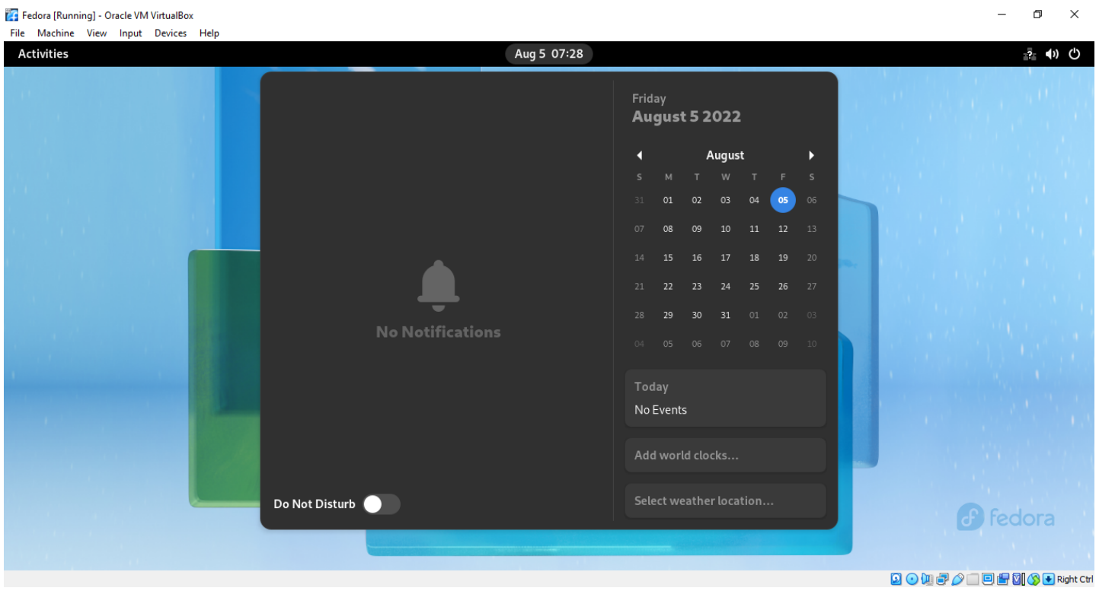

**Compare package managers**

|  |  |
| --- | --- |
| **DNF** | **APT** |
| Dandified Yum | Advanced Package Tool |
| works with .rpm package format | works with .deb package format |
| dnf is the front-end of RPM | apt is the front end of DPKG |
| dnf updates the repo lists automatically | apt update gets all information from configured source |
| dnf is used in RHEL, Fedora, CentOS, and other derivatives pf RHEL | dnf is used in RHEL, Fedora, CentOS, and other derivatives pf RHEL apt is used in Debian and all its derivatives like Ubuntu, Knoppix, etc. |
| can download and install from URLs directly | cannot download and install from URLs directly, it needs .deb packages |
| doesn’t support one-click installs | supports one-click install |
| dnf remove <software name> | Apt remove <software name> |
| dnf upgrade | apt upgrade |
| dnf was first introduced in Fedora in the year 2013 | first stable version of apt was released in the year 2014 |

**Pros/cons of fedora**

**Advantages of Fedora OS-**

1. Fedora OS is a very reliable and stable operating system.
2. It enhances the security in this operating system.
3. It offers many graphical tools.
4. This operating system updates automatically.
5. This OS supports many file formats.
6. It also offers many education softwares.
7. It supports a large community.
8. It provides unique security features

**Disadvantages of Fedora OS-**

1. It requires a long time to set up.
2. It requires additional software tools for the server.
3. It does not provide any standard model for multi-file objects.
4. Fedora has its own server, so we can't work on another server in real time.

**Which one is better for development and why?**

Fedora is geared toward developers and system administrators. fedora is smart auto-configs and various updated packages; that’s why it is the best Linux distro for programmers. Majorly its focuses on the new technology integration, innovation, and focus. This operating system is available in five different editions, Fedora workstation, Fedora server, Fedora core OS, Fedora IoT, Fedora Silverblue each of which serves a specific role. These features makes it better for development and programmers

**Command prompt on Fedora-**

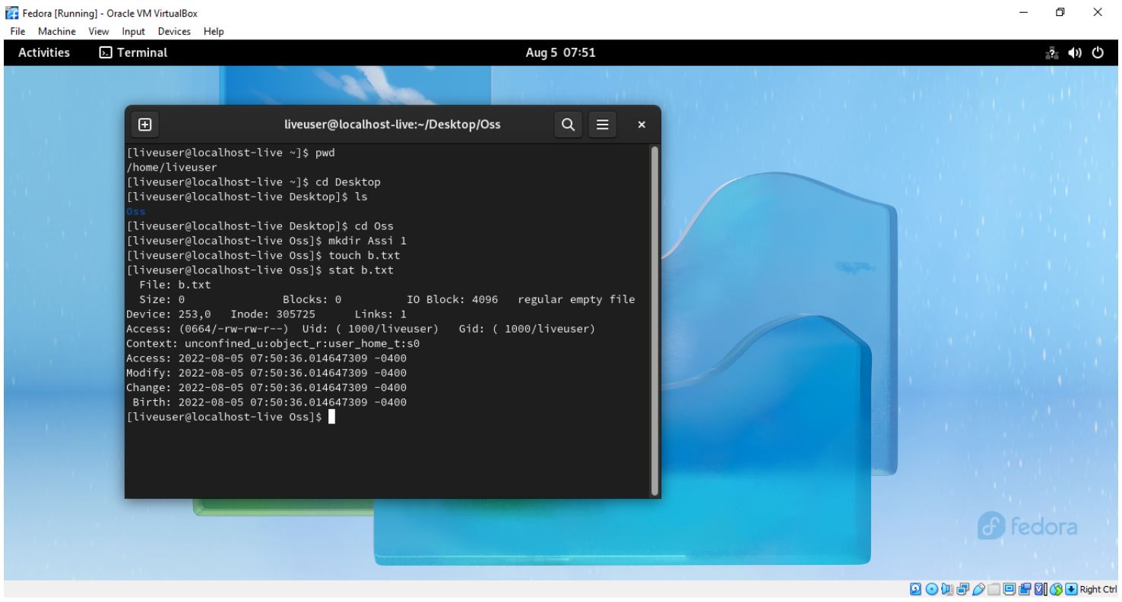

**Commands for Fedora**

1. dnfdragora: A graphical frontend for DNF, the package manager on Fedora. It provides a user-friendly way to manage software packages.
2. dnf system-upgrade: This command is used to perform system upgrades on Fedora. It's specifically designed for upgrading from one Fedora release to the next.
3. rpm-ostree: This is a command-line utility for managing OSTree-based system images, which is a technology used in Fedora Silverblue and CoreOS. It's primarily used for atomic system updates.
4. firewalld: Fedora uses firewalld as a firewall management tool. You can use commands like firewall-cmd to interact with the firewall settings.
5. journalctl: A command for querying and displaying logs from the systemd journal. It's the primary way to access system logs on Fedora.
6. dnf repoquery: This command allows you to query information about packages in your configured repositories. Useful for finding details about packages.
7. dnf list updates: This command lists available updates for your installed packages.
8. dnf history: Used for viewing and managing the package transaction history. You can undo or redo transactions.
9. fedpkg: A tool used to interact with the Fedora packaging system. It's used by Fedora contributors to build and maintain packages for the distribution.
10. beesu: A graphical frontend for the su command, used to run GUI applications with superuser privileges. It's more user-friendly for GUI applications than plain sudo.

**Operating** **system- Debian**

**Various versions of Debian-**

* Debian 1.1 (Buzz)
* Debian 1.2 (Rex)
* Debian 1.3 (Bo)
* Debian 2.0 (Hamm)
* Debian 2.1 (Slink)
* Debian 2.2 (Potato)
* Debian 3.0 (Woody)
* Debian 3.1 (Sarge)
* Debian 4.0 (Etch)
* Debian 5.0 (Lenny)
* Debian 6.0 (Squeeze)
* Debian 7 (Wheezy)
* Debian 8 (Jessie)
* Debian 9 (Stretch)
* Debian 10 (Buster)
* Debian 11 (Bullseye)
* Debian 12 (Bookworm)

**Default desktop GUI of Debian-**

The default desktop environment of Debian is **GNOME**, but if you prefer an alternative desktop environment such as KDE Plasma Desktop or Xfce, you can download a spin for your preferred desktop environment and use that to install Fedora, pre-configured for the desktop environment of your choice

**Main purpose of Debian**

The creation of Debian was sponsored by the FSF’s GNU project for one year (November 1994 to November 1995). Debian was meant to be carefully and conscientiously put together, and to be maintained and supported with similar care. It started as a small, tightly-knit group of Free Software hackers, and gradually grew to become a large, well-organized community of developers and users

**Package management of Debian**

The Apt (Advanced Package Tool) package management system is a set of tools to download, install, remove, upgrade, configure, and manage Debian packages, and therefore all software installed on a Debian system

**List of default packages in Debian**

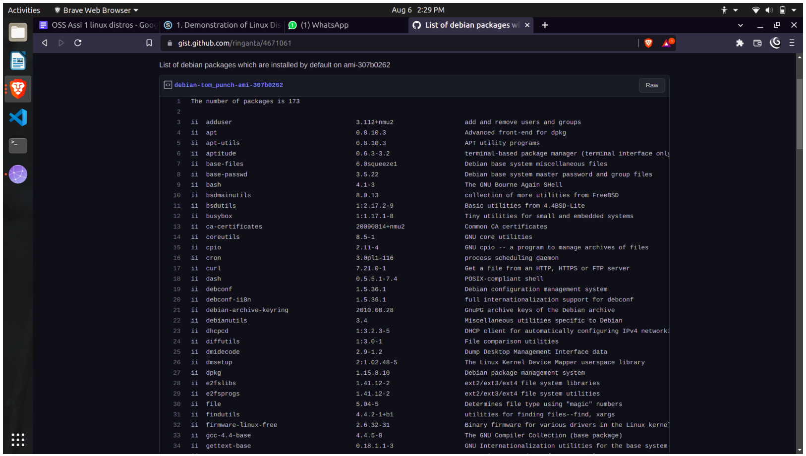

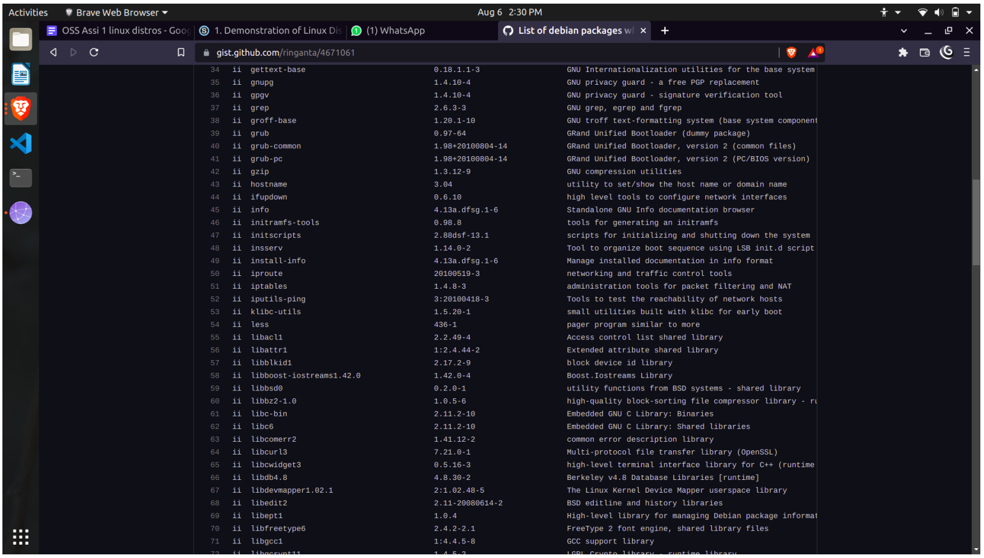

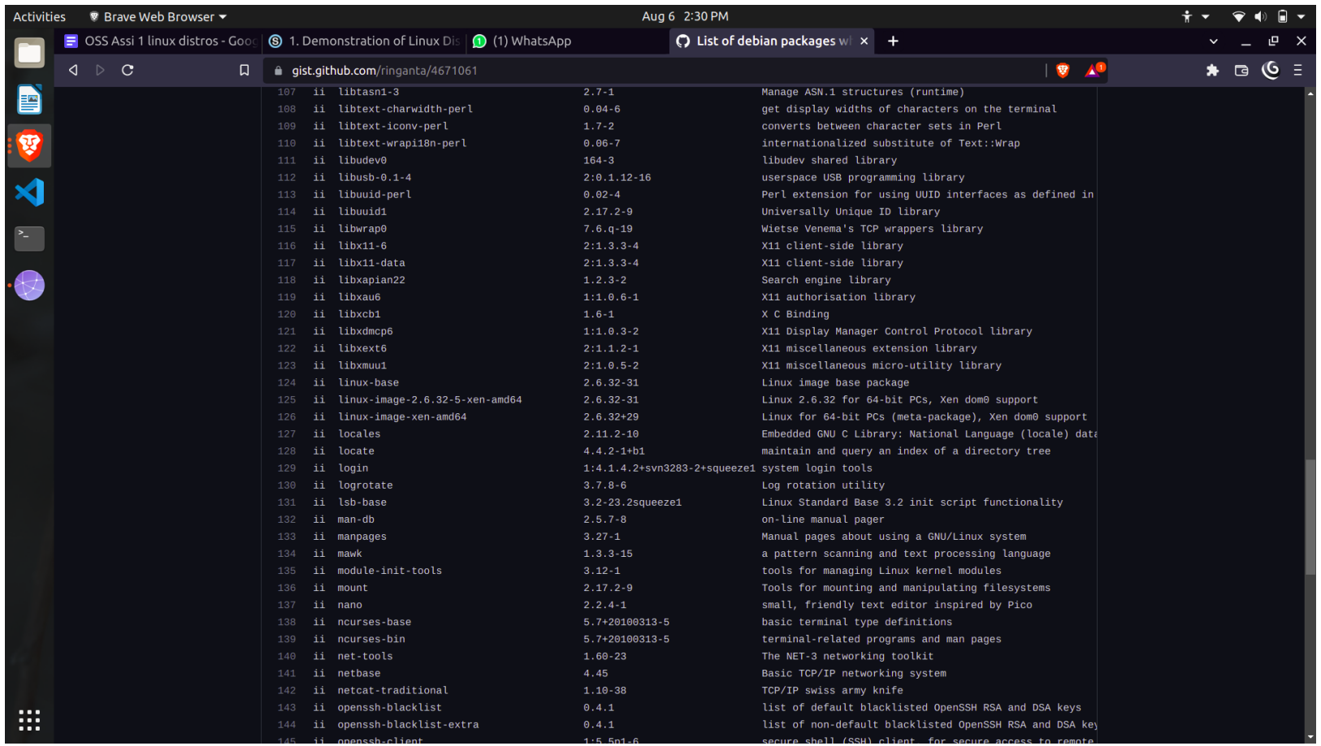

**Screenshots of Debian**

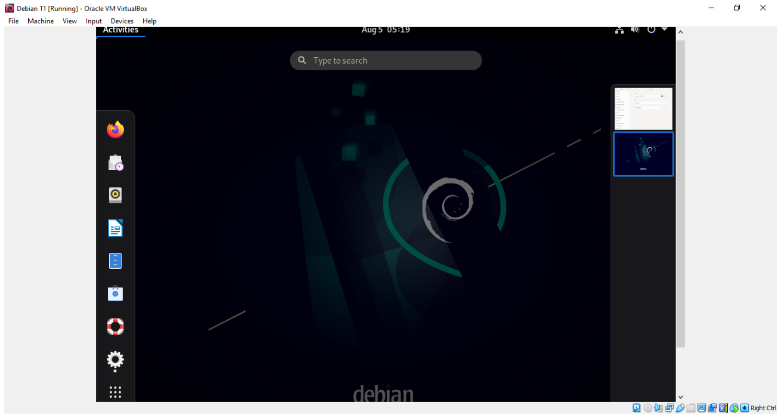

**Pros/cons of Debian**

**Advantages-**

1. Free and Open Source
2. An established linux versions
3. Supports different system architectures
4. Availability of free and proprietary software
5. Specific desktop and server use cases

**Disadvantages-**

1. A conservative operating system
2. Issues with the established GNU Principles

**Which one is easy to use (for beginners) and why?**

Fedora is less user-friendly than Debian. The hardware support is not good as Debian. Fedora is stable but not as much as Debian. Fedora includes less than 20000 packages.

Debian has excellent hardware support. Debian is one of the popular distributions available. Debian is the most stable Linux-based operating system. Debian comes with over 60000 packages.

**Command prompt on Debian-**

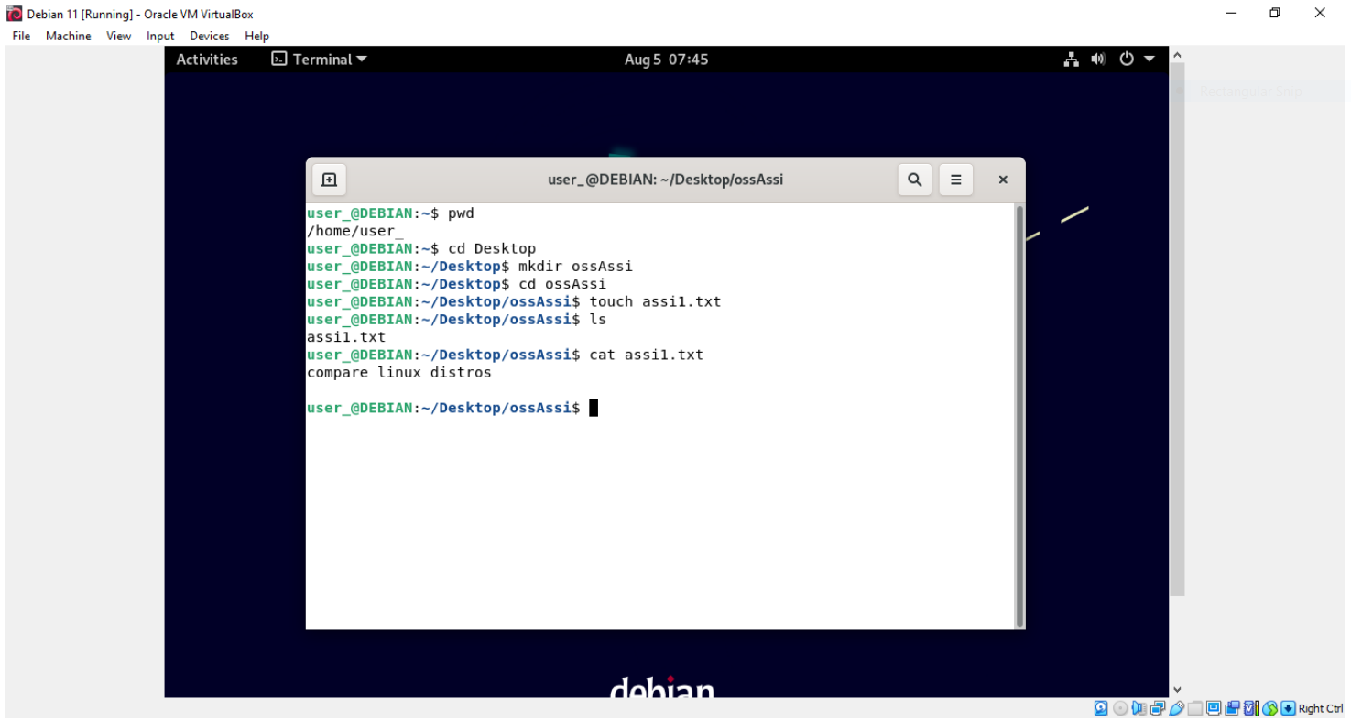

**Commands for Debian**

1. dpkg: A low-level package management command for working with individual .deb packages.
2. systemctl: Similar to Fedora, used to manage systemd-based services on Debian systems.
3. lsb_release: This command displays information about the Linux distribution and its release.
4. ufw: The Uncomplicated Firewall, a user-friendly interface for managing iptables firewall rules.
5. htop: Similar to top, it's a dynamic process viewer and system monitor, but with a more user-friendly interface.
6. debconf: A system for managing configuration prompts during package installation. It's used to present configuration options in a consistent way across different packages.
7. dselect: An older, but still occasionally used, interactive frontend to package management. It provides a text-based interface for selecting and managing packages.

**Conclusion**

1. Installation of various Linux versions.
2. Comparision of various distributions have been studied, and their desktop environments and applications had been studied.